Hardware 1: memory and embedded systems
Y12 - Cambridge International 9618 | 3.1 | Student booklet
Name: _______________________________ | Date: _____________

This booklet has everything you need for the lesson in one place. Work through it in order:
- Learn sections show the key slides. Read them carefully - they explain the ideas and show worked examples.
- Task sections are where you practise. Each task uses what the slides just before it taught you.
- Tasks build up from recall to real Cambridge 9618 Paper 1 questions. Task 5 is homework.
Learn Starter
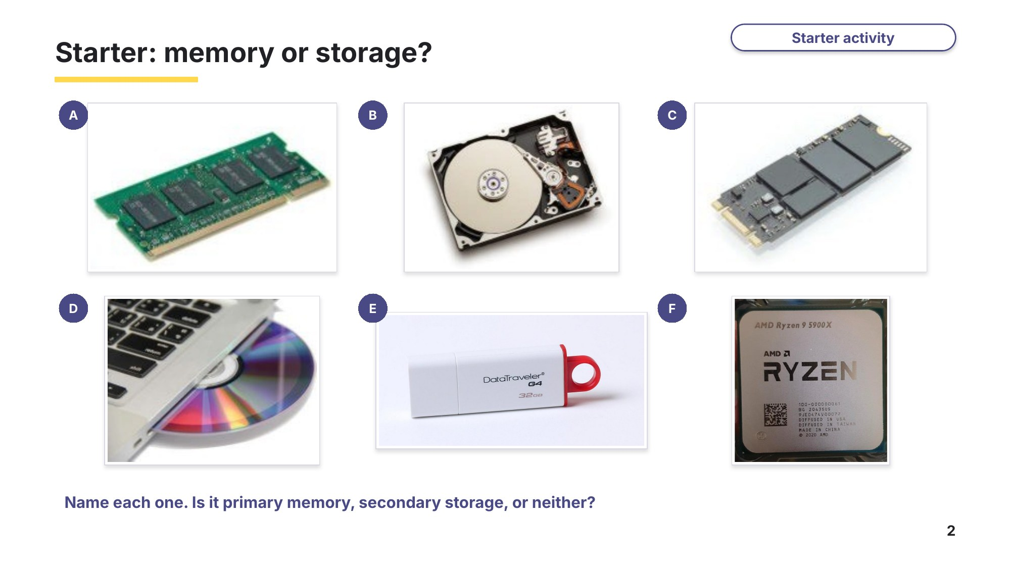
Slide 2 - Starter: memory or storage?

Task 1 Starter: memory or storage? [6 marks]
Look at the photos A to F on the starter slide. Name each component and write whether it is primary memory, secondary storage or neither.
Photo | Name of the component | Primary memory, secondary storage or neither?
A
B
C
D
E
F

Learn Memory and storage
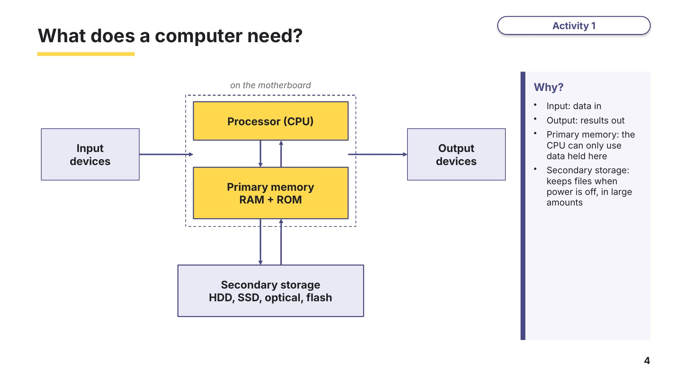
Slide 4 - What does a computer need?
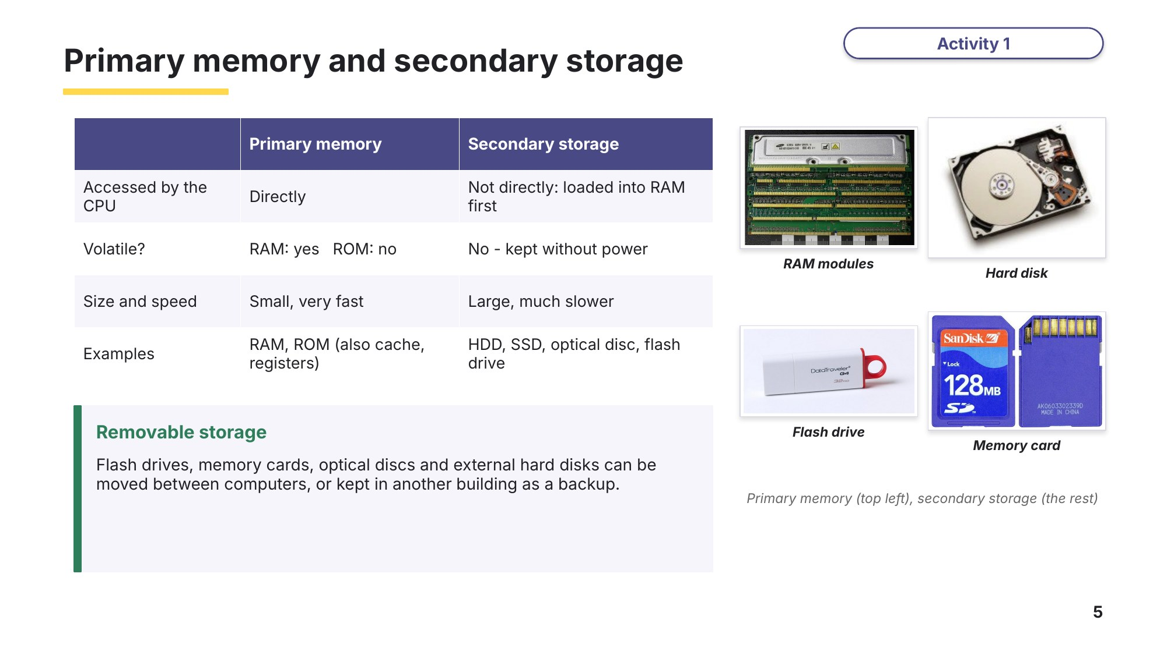
Slide 5 - Primary memory and secondary storage
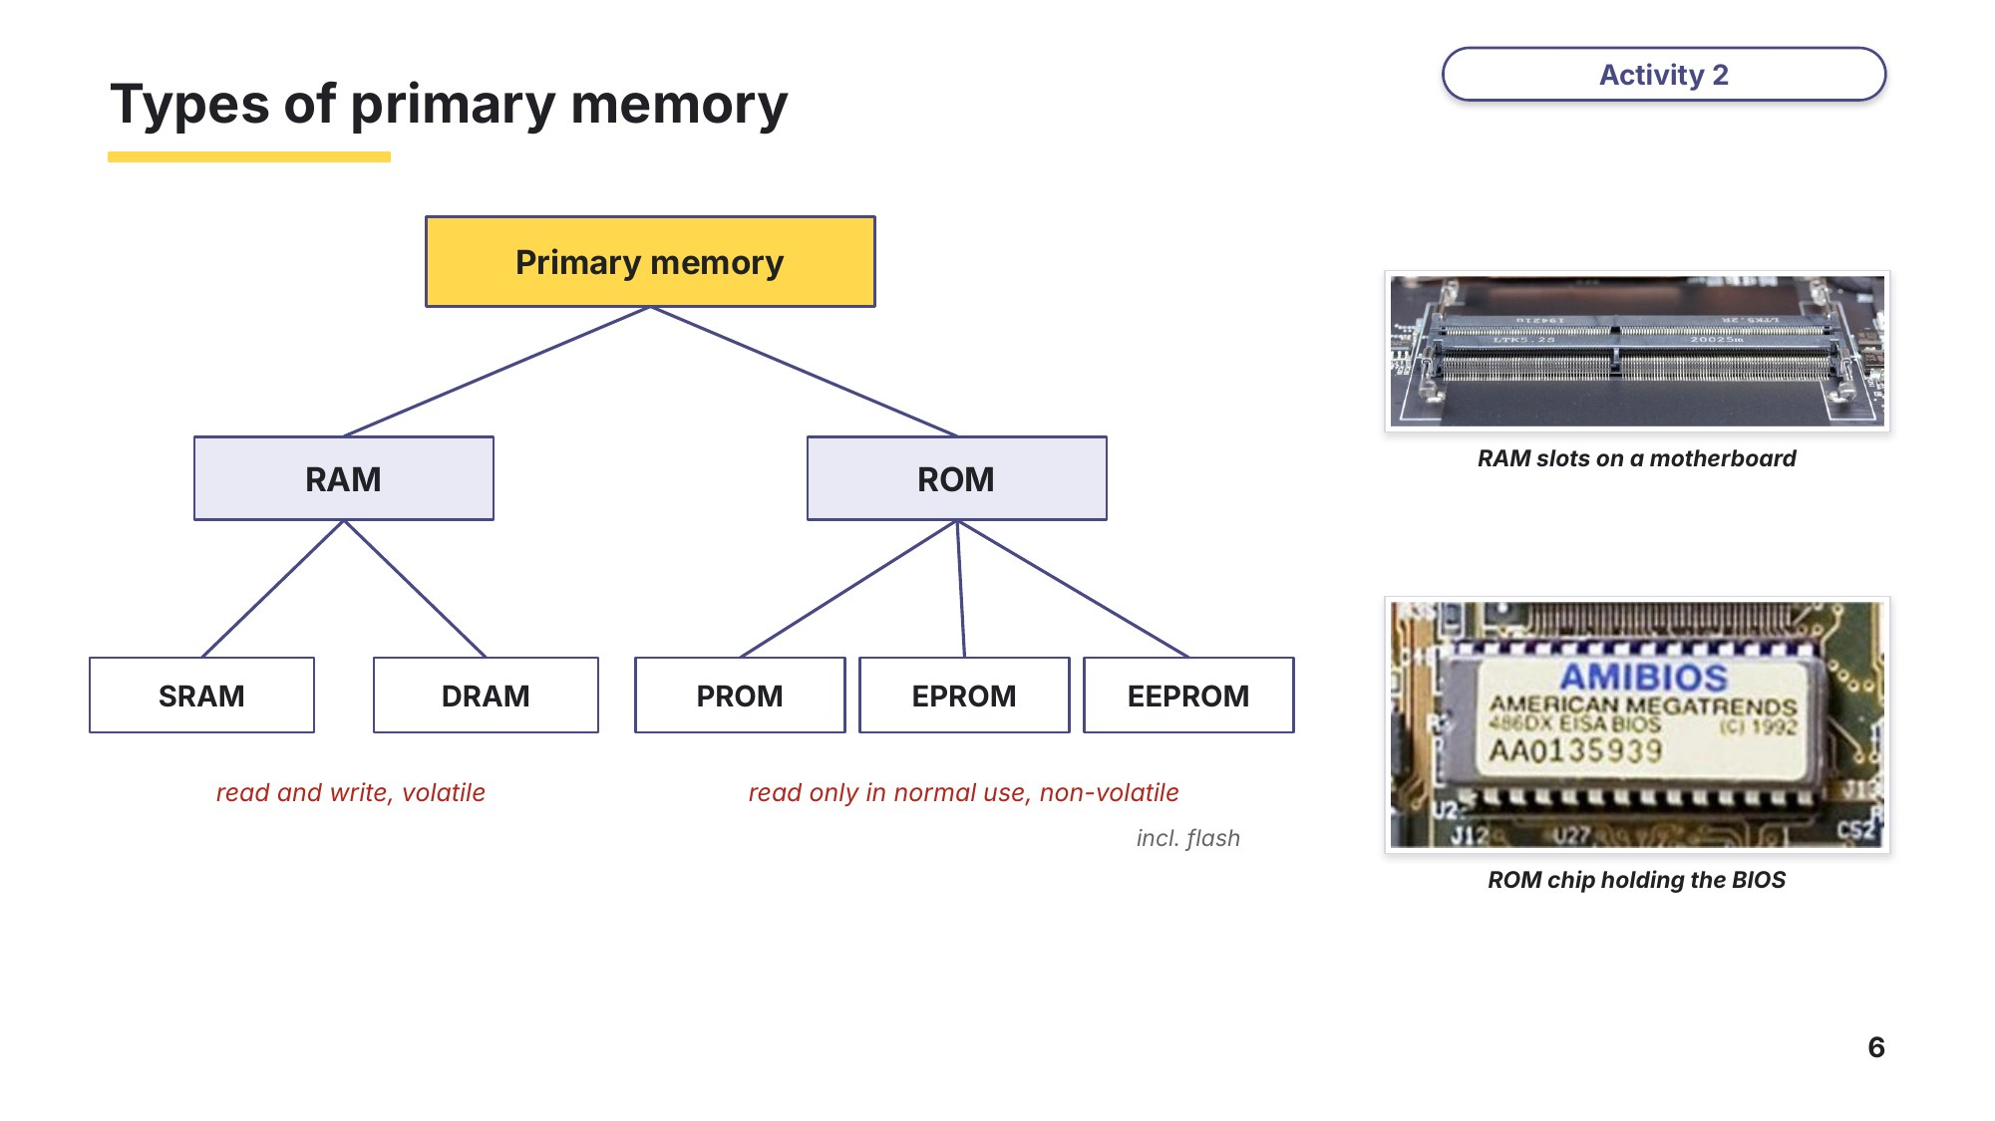
Slide 6 - Types of primary memory
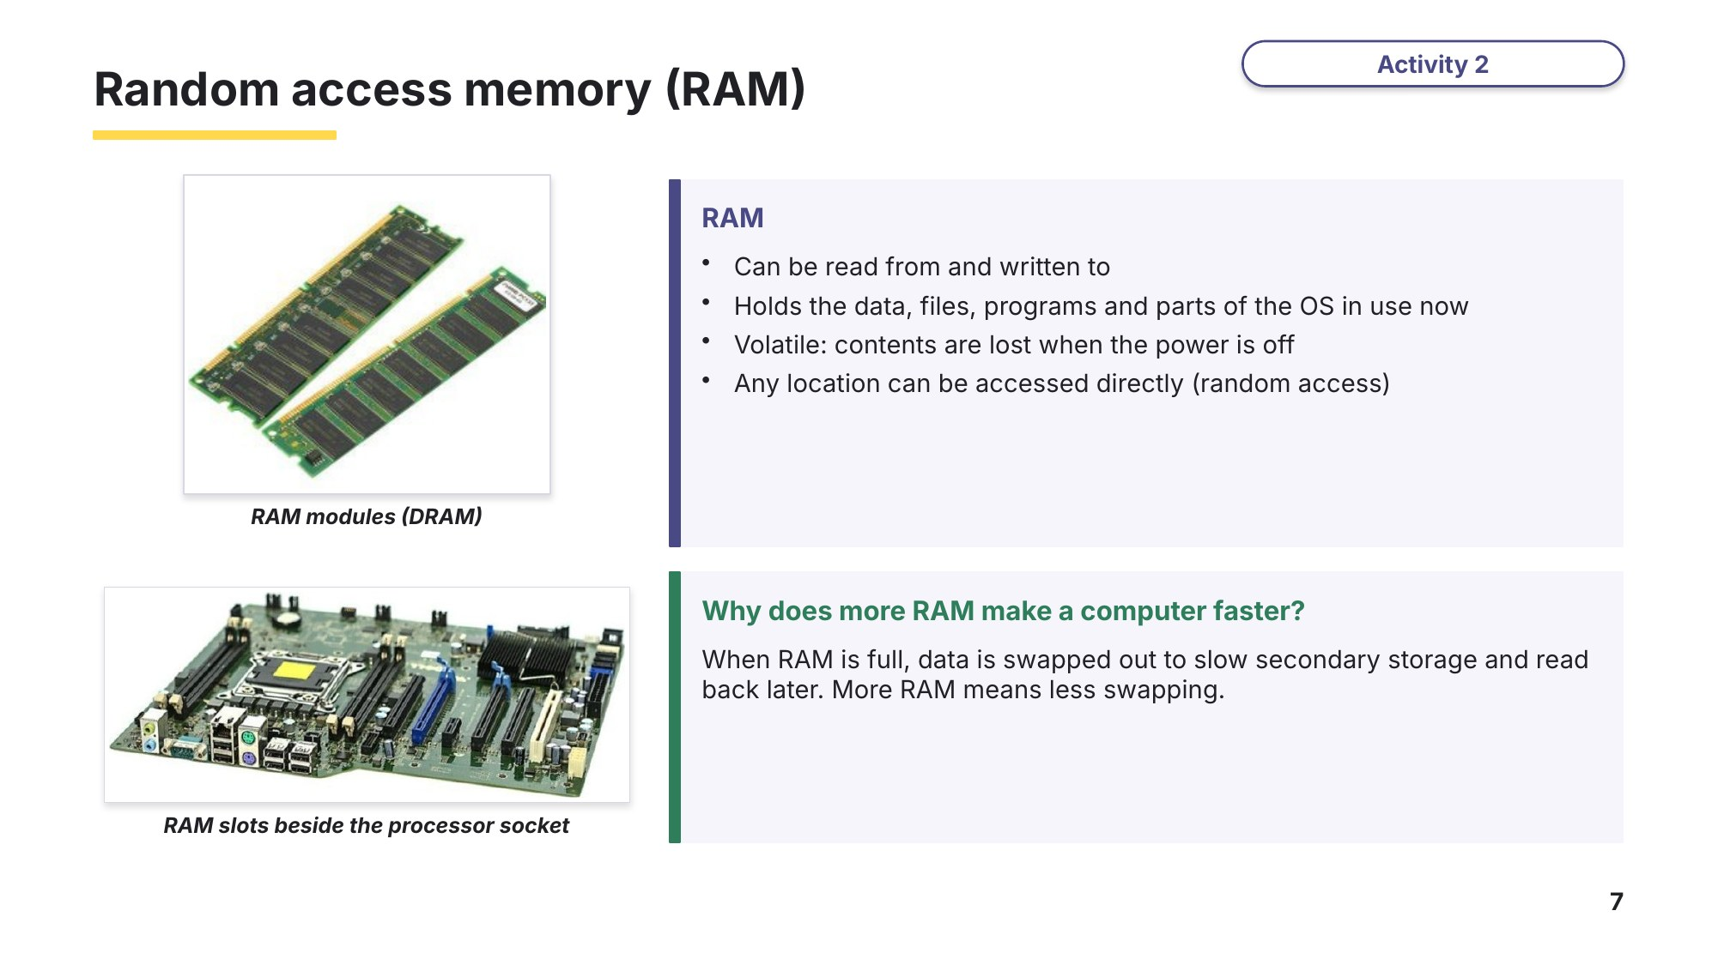
Slide 7 - Random access memory (RAM)
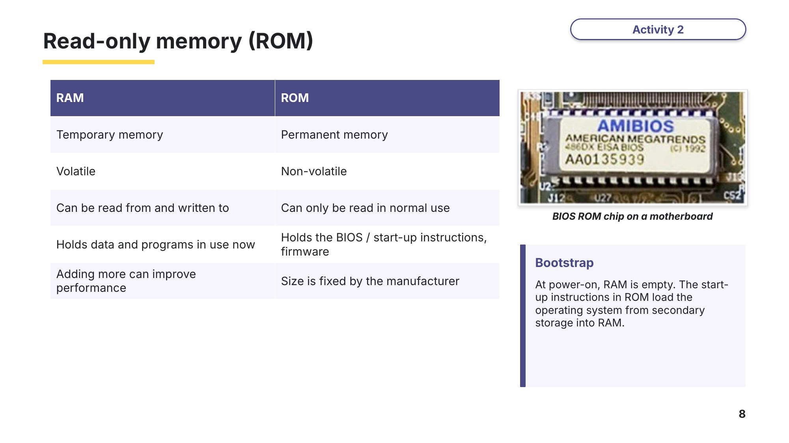
Slide 8 - Read-only memory (ROM)
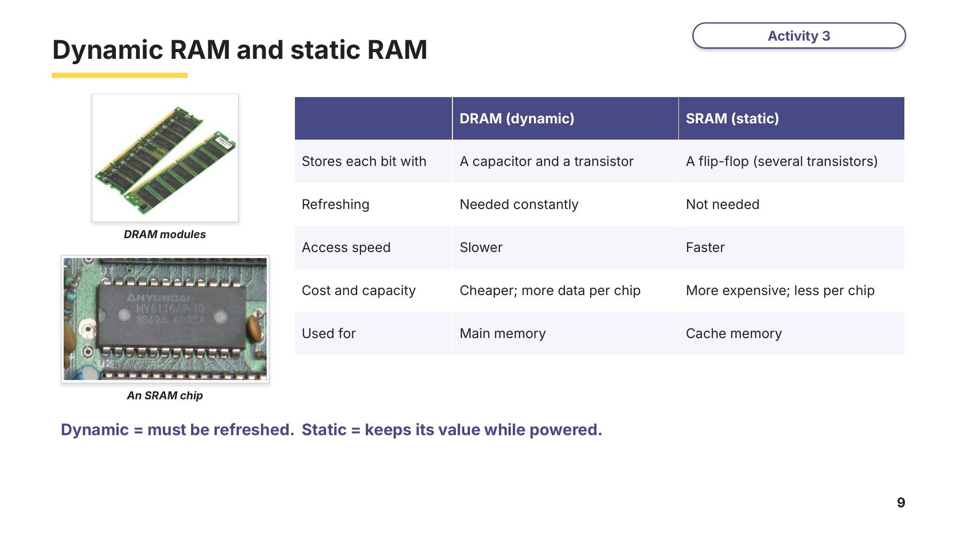
Slide 9 - Dynamic RAM and static RAM
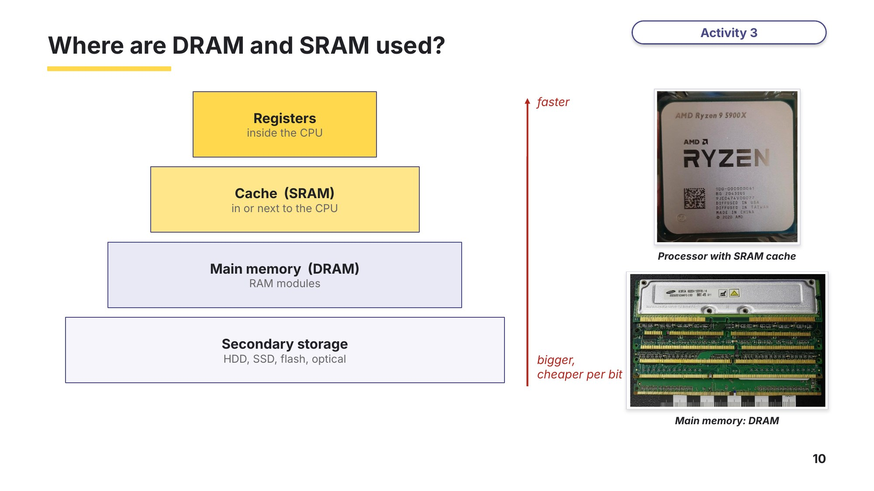
Slide 10 - Where are DRAM and SRAM used?
Task 2 RAM, ROM, DRAM and SRAM [12 marks]
(a) Write RAM or ROM next to each statement. [6]
Statement | RAM or ROM?
Its contents are lost when the power is switched off
It holds the start-up (bootstrap) instructions
It can be written to by the user and by the computer
It holds the parts of the operating system and the programs in use now
It is non-volatile
Adding more of it can improve the performance of the computer

(b) Write DRAM or SRAM next to each statement. [6]
Statement | DRAM or SRAM?
Each bit is stored by a flip-flop
It must be refreshed constantly
Each bit is stored using a capacitor and a transistor
It has faster access times
It is used for the processor's cache memory
It is cheaper to make and stores more data per chip

Learn PROM, EPROM and EEPROM
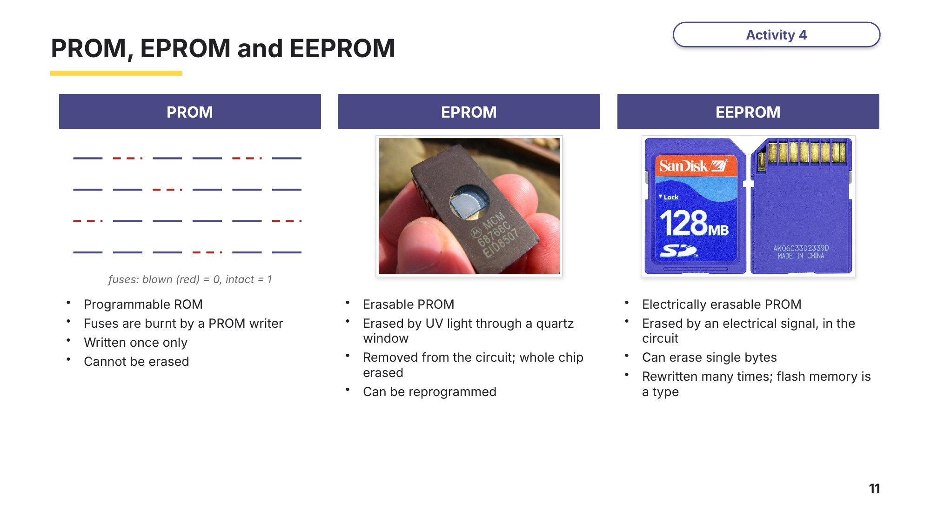
Slide 11 - PROM, EPROM and EEPROM
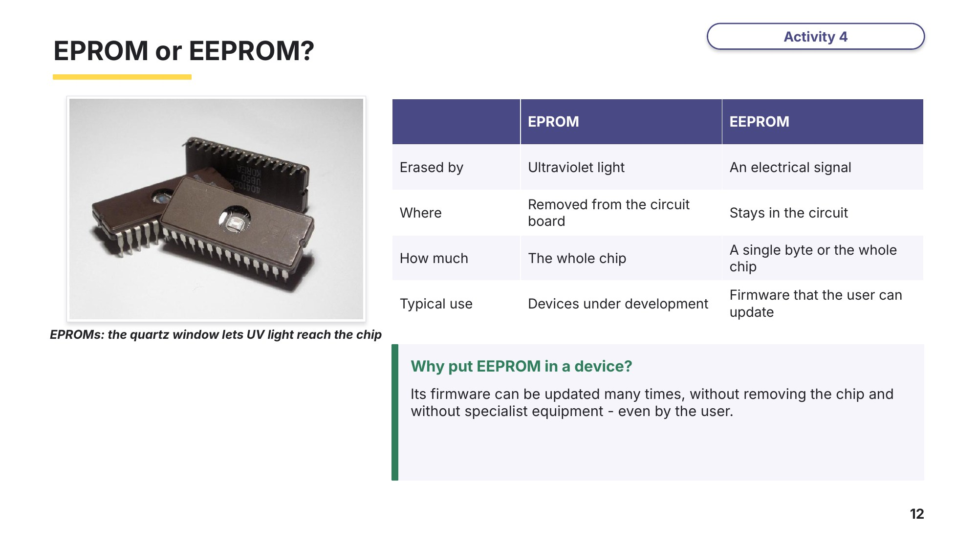
Slide 12 - EPROM or EEPROM?
Task 3 PROM, EPROM and EEPROM [7 marks]
(a) Tick (✓) the type or types of ROM that each statement describes. A statement can describe more than one type. [5]
Statement | PROM | EPROM | EEPROM
It can be programmed only once
It is erased using ultraviolet light
It can be erased and reprogrammed while still in the circuit
It can be erased and reprogrammed more than once
It is programmed by burning fuses

(b) A games console company wants to send updates for the console's firmware over the internet. Identify the type of ROM the console should use and explain your choice. [2]

Learn Embedded systems
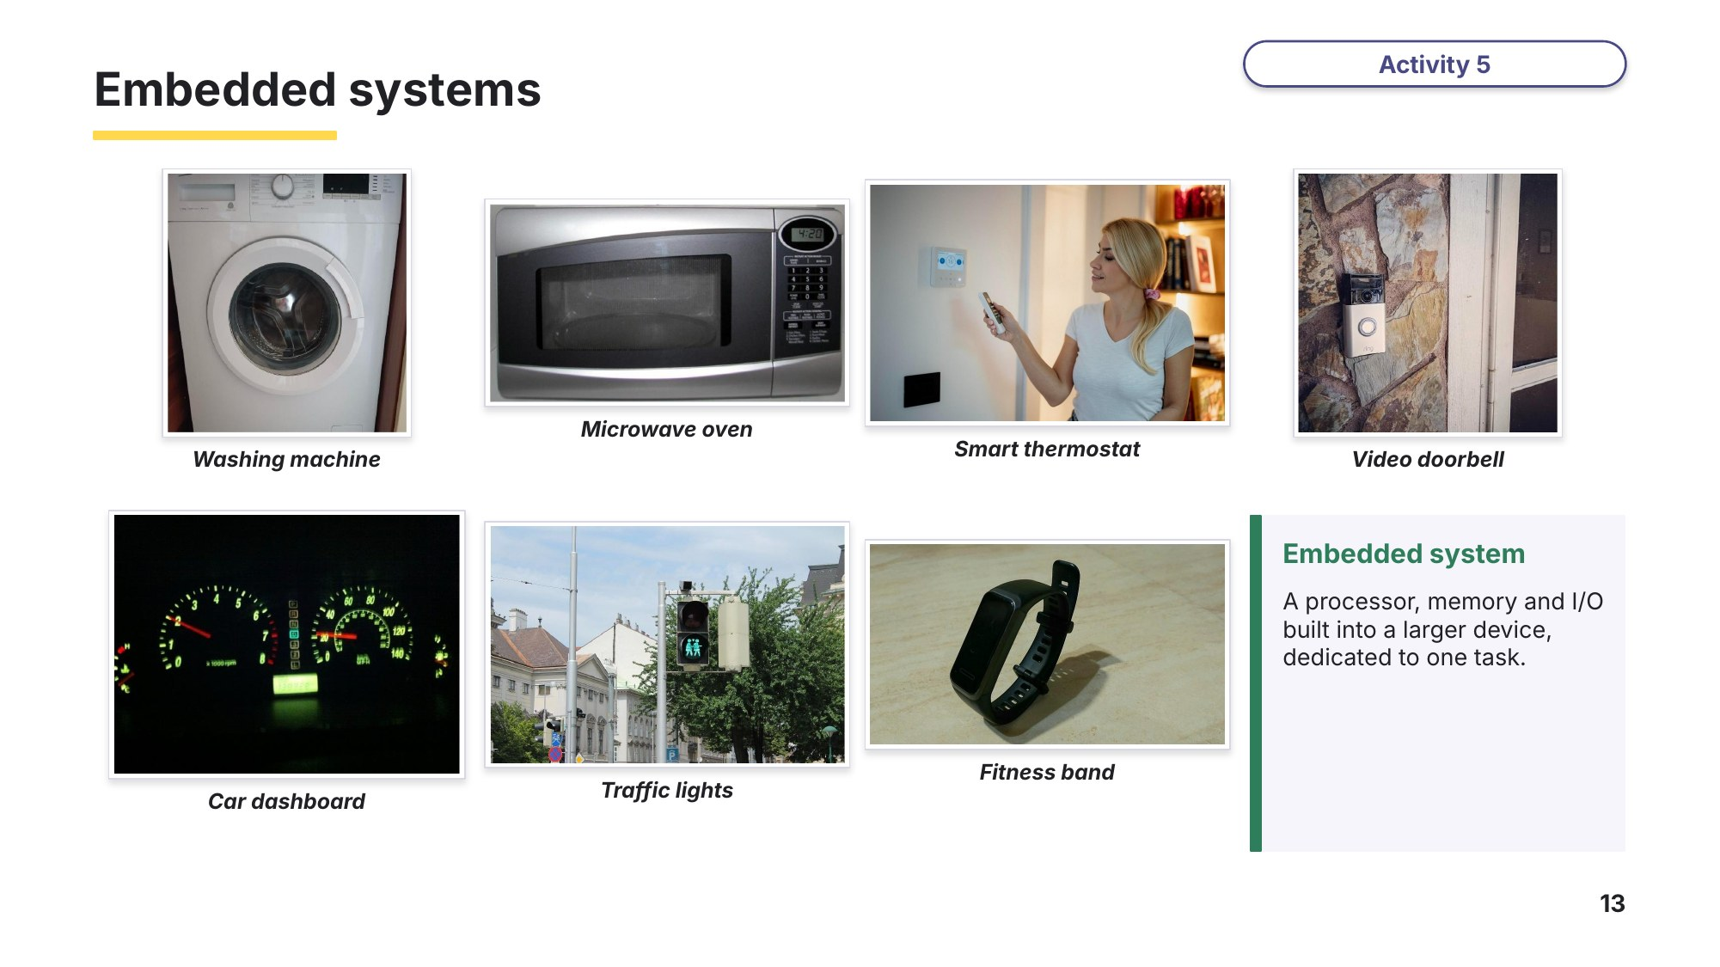
Slide 13 - Embedded systems
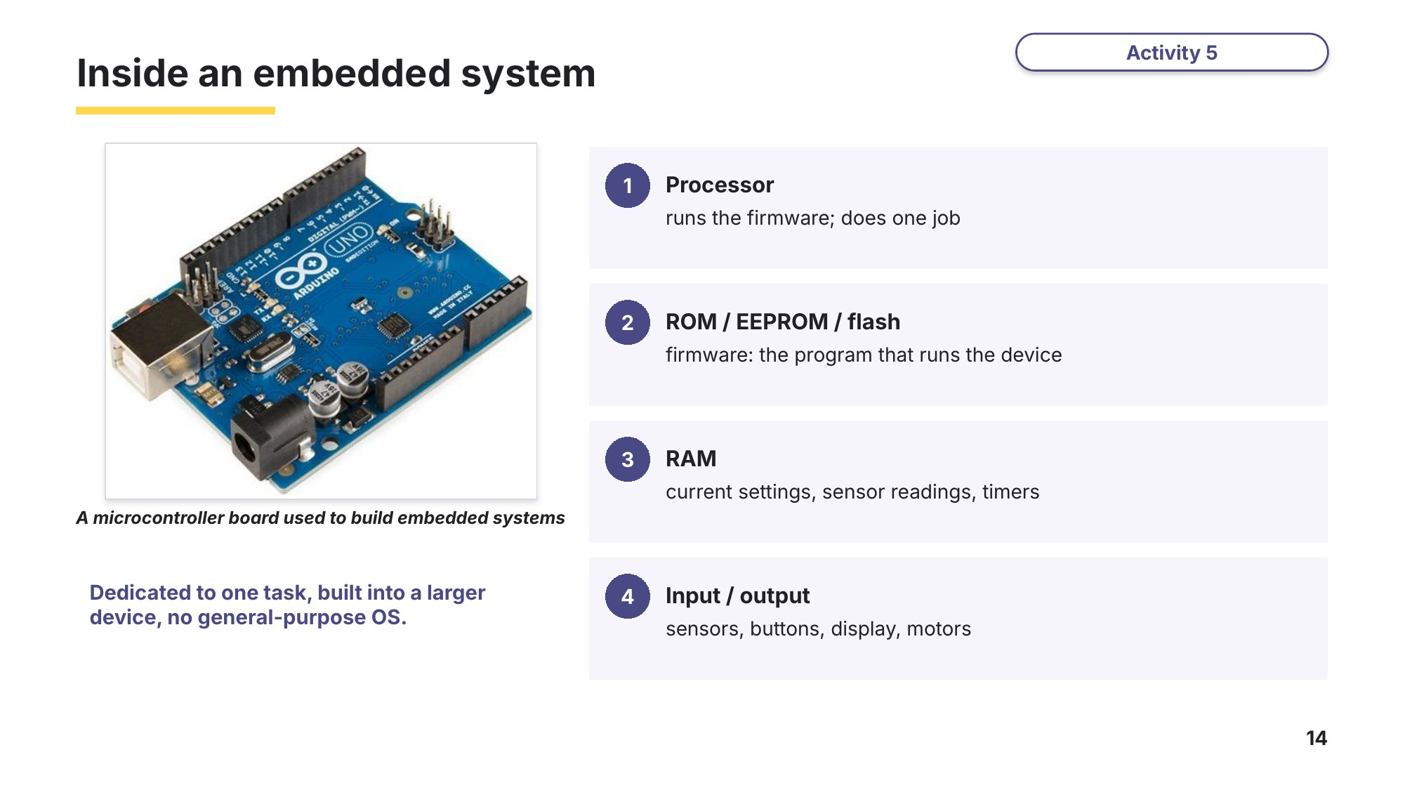
Slide 14 - Inside an embedded system
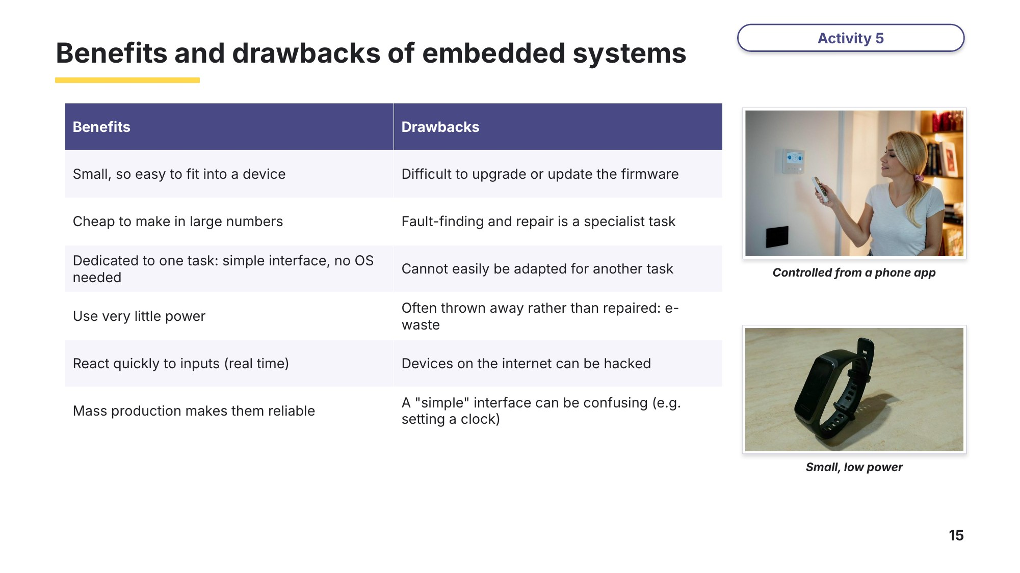
Slide 15 - Benefits and drawbacks of embedded systems
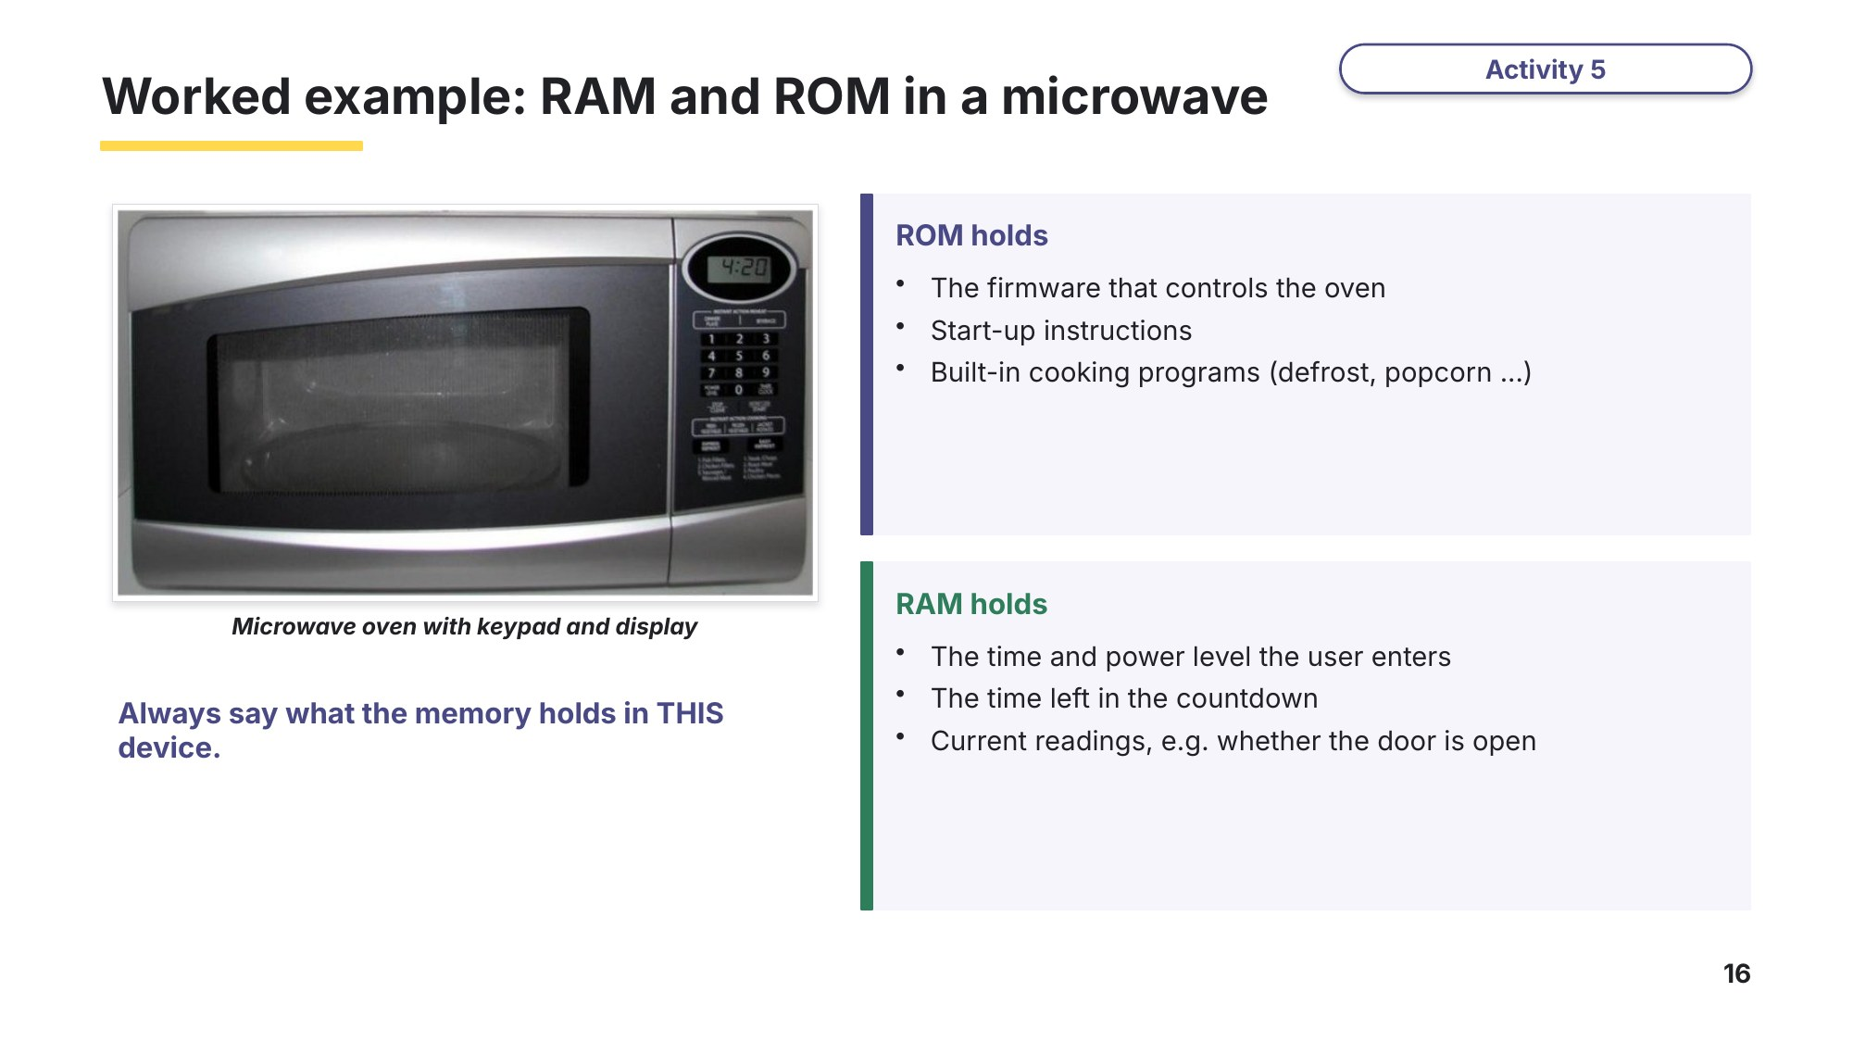
Slide 16 - Worked example: RAM and ROM in a microwave

Task 4 Embedded systems [9 marks]
(a) Write E if the device contains an embedded system, or G if it is a general-purpose computer. [3]
Device | E or G? | Device | E or G?
Washing machine |  | Desktop PC
Laptop |  | Traffic light controller
Car engine management system |  | Video doorbell

(b) Write B if the statement is a benefit of embedded systems, or D if it is a drawback. [4]
Statement | B or D?
They use very little power
It is difficult for the user to update the firmware
They are cheap to make in large numbers
Faulty devices are often thrown away rather than repaired

(c) A smart thermostat controls the heating in a house. The user sets the temperature using an app. Describe what the thermostat stores in its ROM and in its RAM. [3]
ROM stores | RAM stores

Learn Exam technique
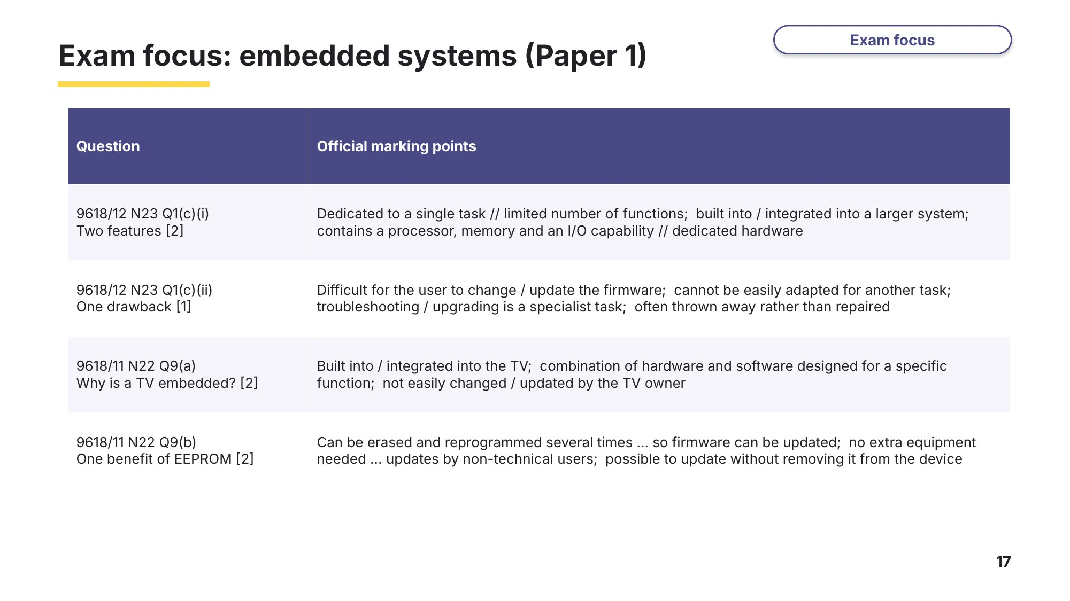
Slide 17 - Exam focus: embedded systems (Paper 1)
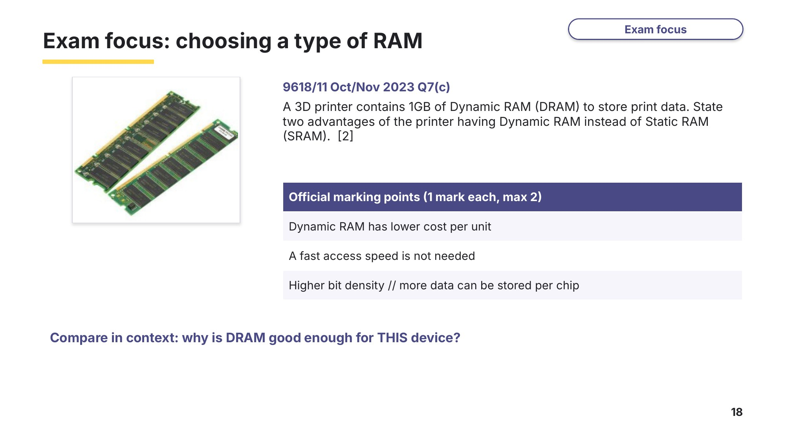
Slide 18 - Exam focus: choosing a type of RAM
Task 5 Real exam questions - homework [27 marks]
All questions are from Cambridge 9618 Paper 1.
Kiara has a washing machine. She has an embedded system in her washing machine.
(a) (i) Describe what is meant by an embedded system, using the washing machine as an example. [2]
9618/11 May/June 2021 Q5(a).

The washing machine's embedded system makes use of both Random Access Memory (RAM) and Read Only Memory (ROM).
(ii) State the purpose of RAM and ROM within the washing machine's embedded system. [2]
9618/11 May/June 2021 Q5(b).
RAM

ROM

(b) Embedded systems contain Read Only Memory (ROM) and Random Access Memory (RAM). Explain the reasons why ROM is used in an embedded system. [2]
9618/12 October/November 2022 Q3(c).

A networked closed-circuit television (CCTV) system in a house uses sensors and cameras to detect the presence of a person. It then tracks the person and records a video of their movements. Data from the CCTV cameras is transmitted to a central computer.
(c) (i) Describe the contents of the ROM in the central computer. [2]
9618/11 May/June 2023 Q4(a)(i).

(ii) The central computer has Dynamic RAM (DRAM). Identify two advantages of using DRAM instead of Static RAM (SRAM). [2]
9618/11 May/June 2023 Q4(a)(ii).
1

2

(d) Identify two disadvantages of using Dynamic RAM (DRAM) instead of Static RAM (SRAM) in a computer system. [2]
9618/11 October/November 2024 Q3(c).
1

2

Embedded systems are used in many electronic devices.
(e) (i) Describe the drawbacks of embedded systems. [3]
9618/12 October/November 2024 Q2(a).

(ii) Give two differences between Erasable Programmable ROM (EPROM) and Electrically Erasable Programmable ROM (EEPROM). [2]
9618/12 October/November 2024 Q2(c).
1

2

(f) A virtual reality (VR) headset has Electrically Erasable Programmable Read Only Memory (EEPROM). Explain the benefits of using EEPROM instead of other types of Read Only Memory (ROM) in the VR headset. [3]
9618/12 May/June 2024 Q2(c).

A video doorbell is attached to the front door of a house. The doorbell uses a motion sensor to detect when a visitor walks in front of the door. When the motion sensor is activated, the digital camera in the doorbell starts recording a video, and a message is transmitted to a smartphone so that the person who lives in the house can watch the video.
(g) (i) The video doorbell can be considered an example of an embedded system. Identify two characteristics of the doorbell that suggest it is an embedded system. [2]
9618/11 May/June 2024 Q2(a).
1

2

(ii) The video doorbell has both primary memory and secondary storage. Identify two items of data that the video doorbell will store in primary memory. [2]
9618/11 May/June 2024 Q2(c)(i).
1

2

(h) Give one example of an embedded system and explain why it is an example of an embedded system. [3]
9618/11 October/November 2023 Q9(b).
Example

Explanation

Learn Review
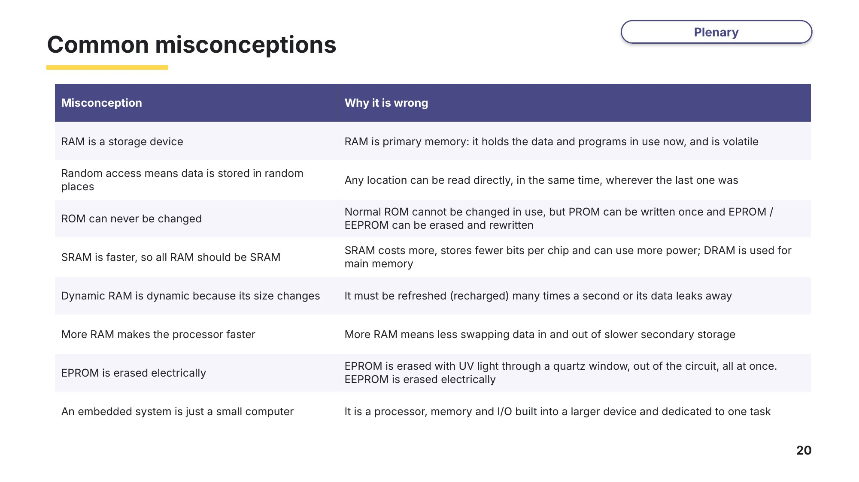
Slide 20 - Common misconceptions
Which of these did you believe before this lesson?
Exit question
(a) Give two differences between RAM and ROM. [2]

(b) Explain why cache memory is made from SRAM and not DRAM. [1]

(c) Identify one drawback of embedded systems. [1]

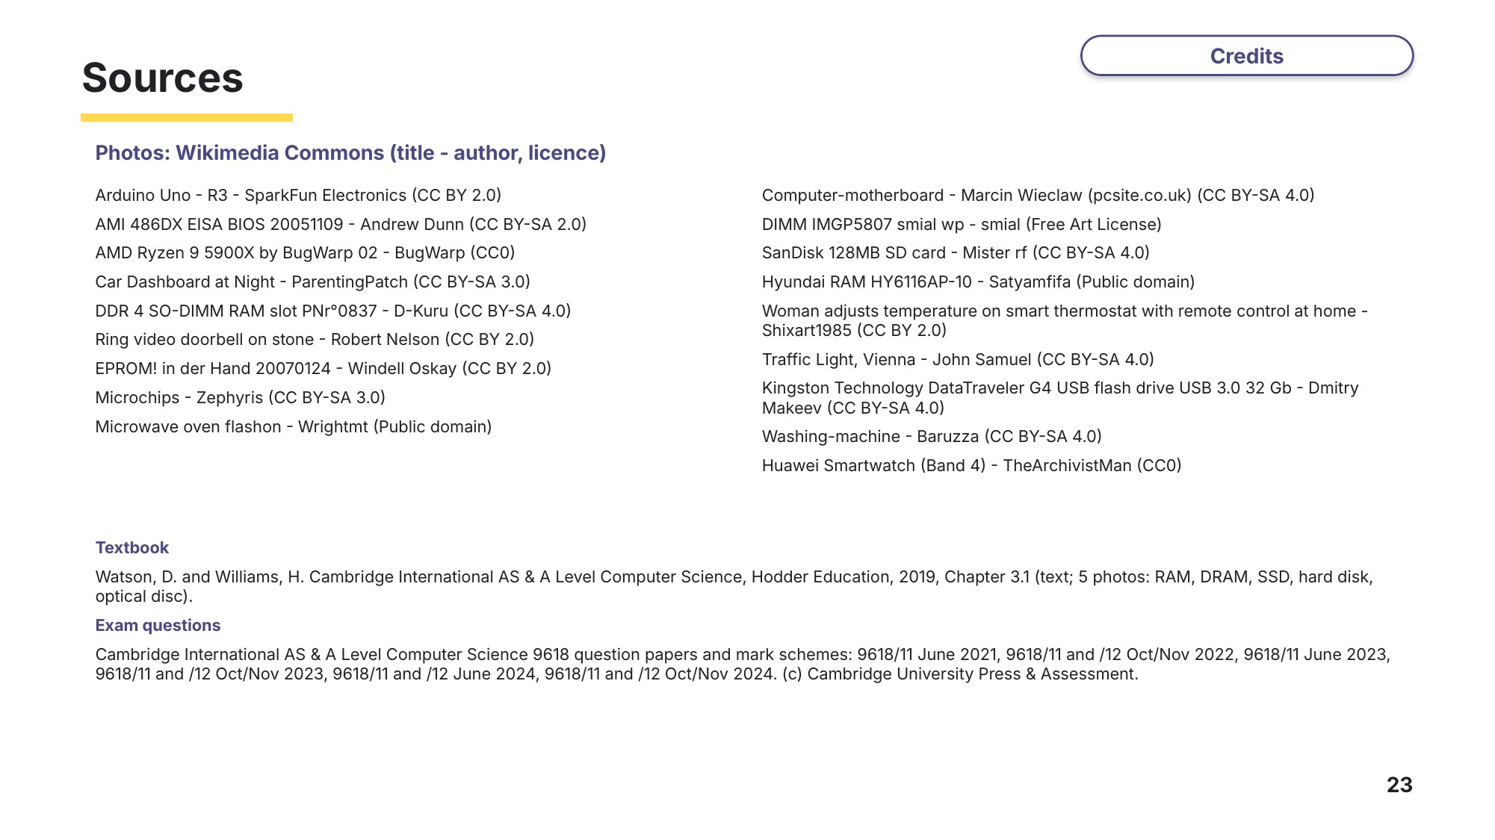
Slide 23 - Sources

